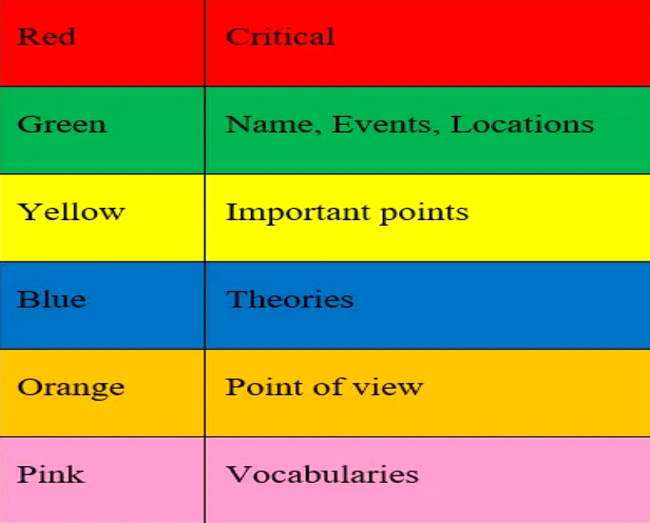
HTML code
<!DOCTYPE html>
<html lang="en">
<head>
<meta charset="UTF-8">
<meta name="viewport" content="width=device-width, initial-scale=1.0">
<title>Colored Table</title>
<style>
/* Apply styles to the table */
table {
width: 100%;
border-collapse: collapse;
}

/* Define colors for each row */
.red {
background-color: red;
}

.green {
background-color: green;
}

.yellow {
background-color: yellow;
color: black; /* Adjust text color for visibility */
}

.blue {
background-color: blue;
}

.orange {
background-color: orange;
}

.pink {
background-color: pink;
color: black; /* Adjust text color for visibility */
}

/* Style for table cells (optional) */
td {
padding: 20px;
font-weight: bold;
text-align: center;
border:2px solid black
}
</style>
</head>
<body>
<h1>Color-Coded Information</h1>
<table>
<tr>
<td class="red">Red</td>
<td class="red">Critical</td>
</tr>
<tr>
<td class="green">Green</td>
<td class="green">Name, Events, Locations</td>
</tr>
<tr>
<td class="yellow">Yellow</td>
<td class="yellow">Important points</td>
</tr>
<tr>
<td class="blue">Blue</td>
<td class="blue">Theories</td>
</tr>
<tr>
<td class="orange">Orange</td>
<td class="orange">Point of view</td>
</tr>
<tr>
<td class="pink">Pink</td>
<td class="pink">Vocabularies</td>
</tr>

</table>
</body>
</html>

